**Random Forest:**

* Feature Selection by 5 fold Cross-Validations and Check importance plot to remove non-significant predictors (Start with 22 variables, end with 12 variables).

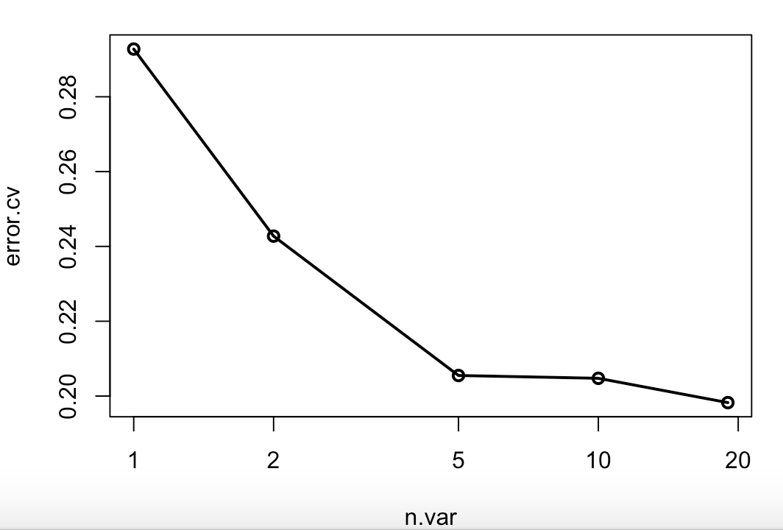

* Rebuild model with 12 predictors with optimal parameter which 500 of trees to grow, and 3 variables randomly sampled as candidates at each split.

Tune RandomForest for the optimal mtry parameter:

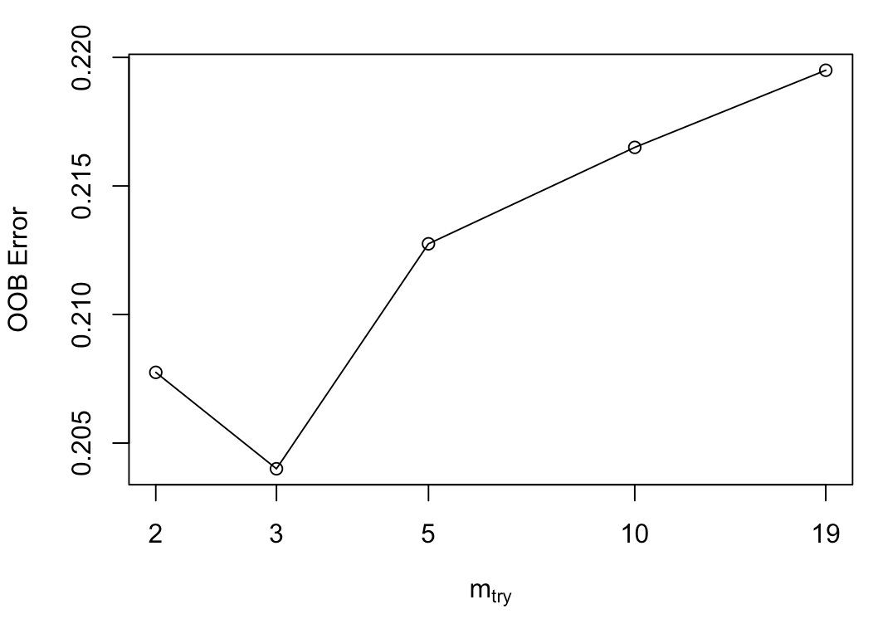

**SVM:**

* **Normalize dataset:** SVMs assume that the data it works with is in a standard range, usually either 0 to 1, or -1 to 1 (roughly). So the normalization of feature vectors prior to feeding them to the SVM is very important. We did a 'soft' normalization which subtracts the mean of the values and divides by the standard deviation on our both training and testing dataset.
* **Parameters selection (cost and gamma) by 10-folds CV:** The slack variable cost) and gamma (the width of the Gaussian if using an RBF kernel: 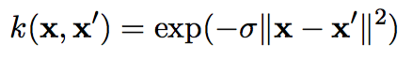)values. These are searched in exponential factors: for C, range = (0.1, 1, 10, 100, 1000) and for gamma, range = (0.1, 0.01, 0.001, 0.0001, 0.00001). Our optimal parameters is cost = 0.1, and gamma 0.1.

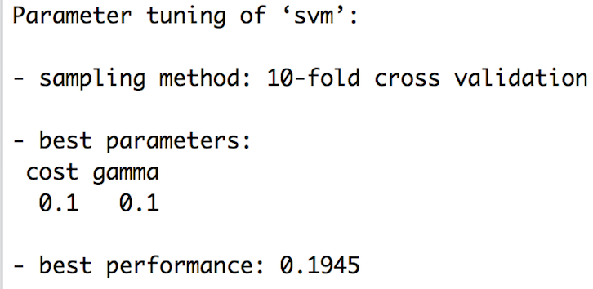

* **Train the model with optimal parameters (cost = 0.1, gamma = 0.1) with 10-folds CV.**



**AdaBoosting&Bagging:**

* **Normalize dataset: same as SVM, we normalized our dataset first.**
* **Logical Parameter:** Total of 50 of iterations for which boosting is run or the number of trees to use. Additionally, a bootstrap sample of the training set is drawn using the weights for each observation on that iteration. In the logical argument coeflearn = "Breiman" which the alpha = 1/2 ln((1 eb)/eb) is used.
* **Classification tree:**



* The method of the bagging function produces an object of class bagging, which is a list with almost the same components as boosting. The only difference is the matrix with the bootstrap samples used along the iterations instead of the weights of the trees.

**Extreme Gradient Boosting:** an implementation of the famous gradient boosting algorithm. This model is often described as a *blackbox*, meaning it works well but it is not trivial to understand how. Indeed, the model is made of hundreds of decision trees.

* **Normalize dataset:** We first normalized our dataset and convert both datasets (training and test) in numeric Matrix format.
* **Optimal Parameters for Tree/Linear Booster:** eta = 0.001 (control the learning rate), which used to prevent overfitting by making the boosting process more conservative. (for tree only). max.depth = 4, maximum depth of a tree (for tree only). subsample = 0.8, randomly collected 80% of the data instances to grow trees and this will prevent overfitting.

Tree Booster converged at 7th iteration Linear Booster converged at 2th iteration

